Assignment-1_COMP3133

Karan Parmar
101427974

Sample user:

1. "id": "67afb701ef9a33bb4b9d8b2f",
"first_name": "Bob",
"last_name": "Smith",
"email": "bob.smith@example.com",
"gender": "Male",
"designation": "Senior Developer",
"salary": 12000

2. "id": "67afb8189e9035f10f076f6d",
"first_name": "Joker",
"last_name": "Deker",
"email": "john.doe@example.com",
"gender": "Male",
"designation": " Engineer",
"salary": 800000

To delete an employee using POST method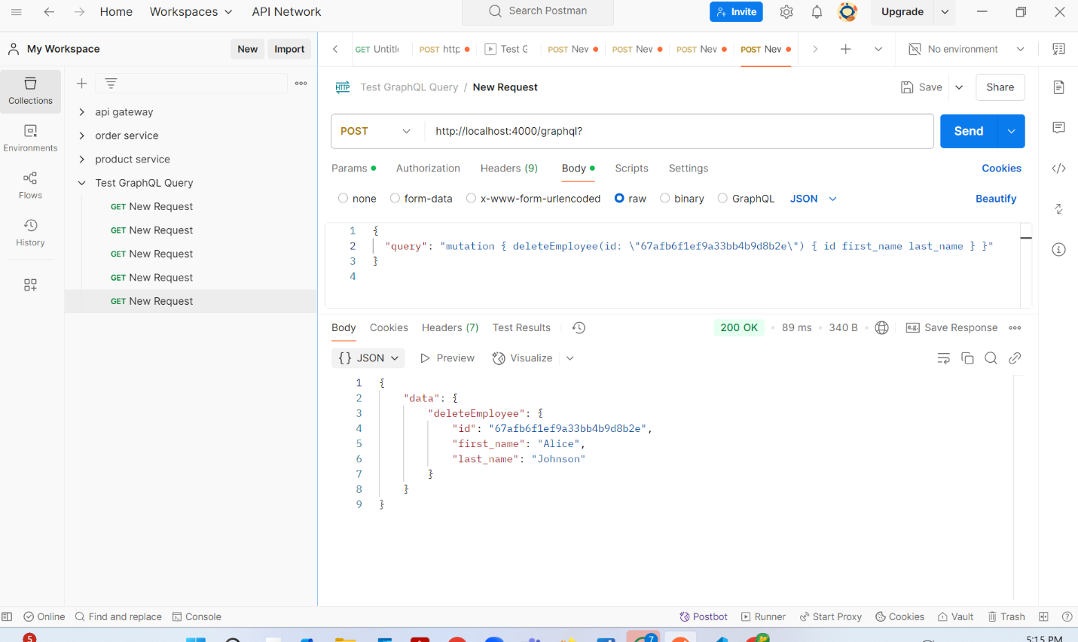To Update Employee Info using POST method 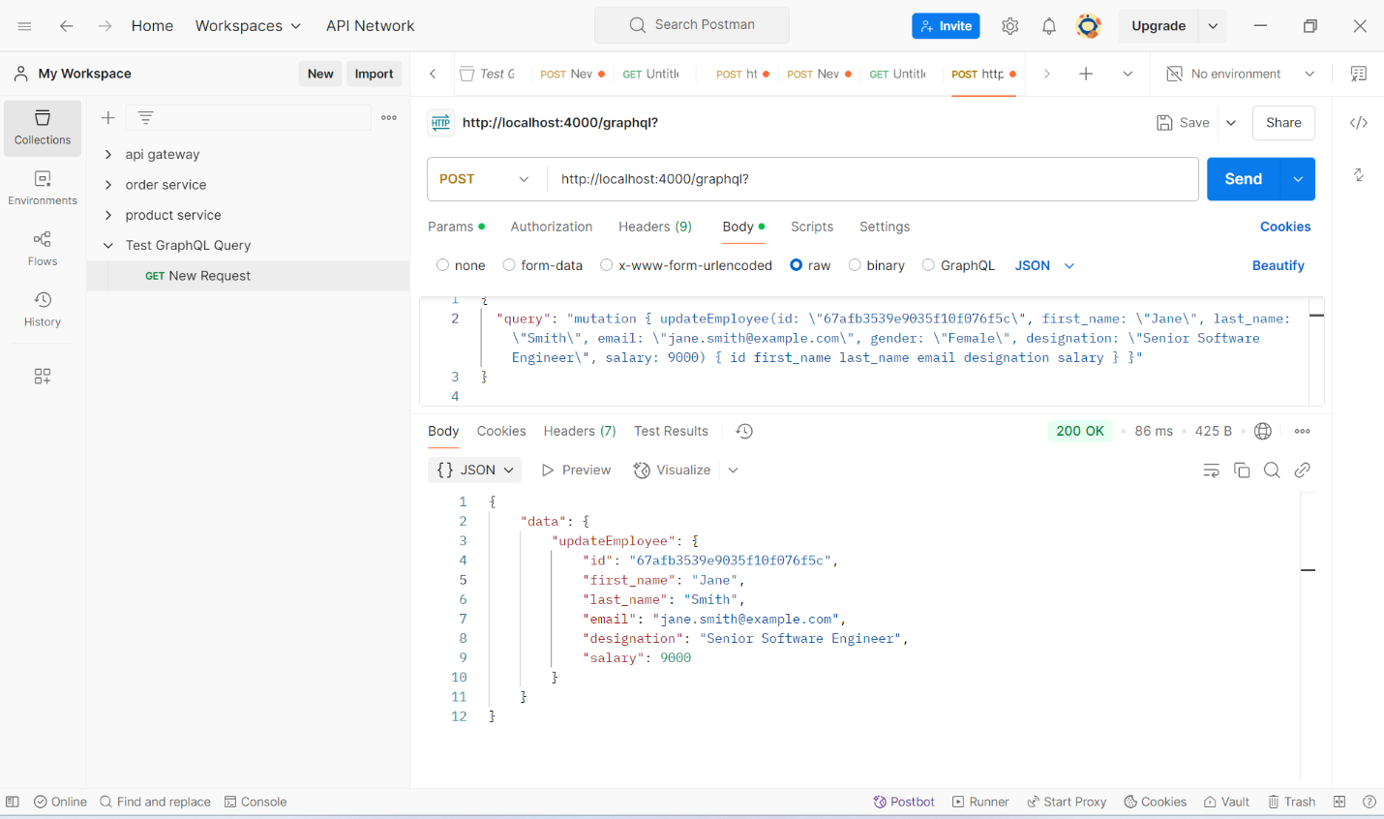
To add an employee using POST method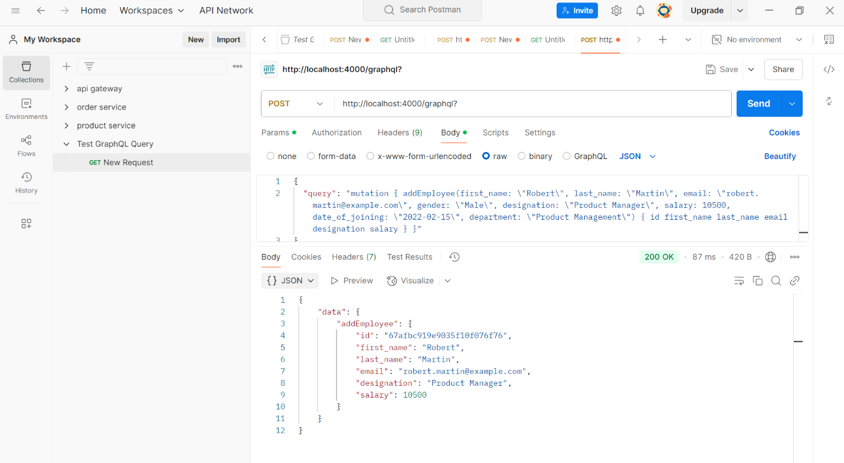To get an employee by ID using POST method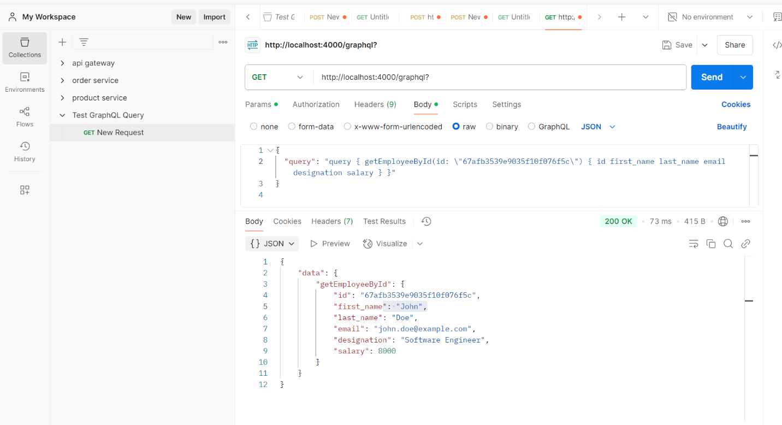
To get all employees using POST method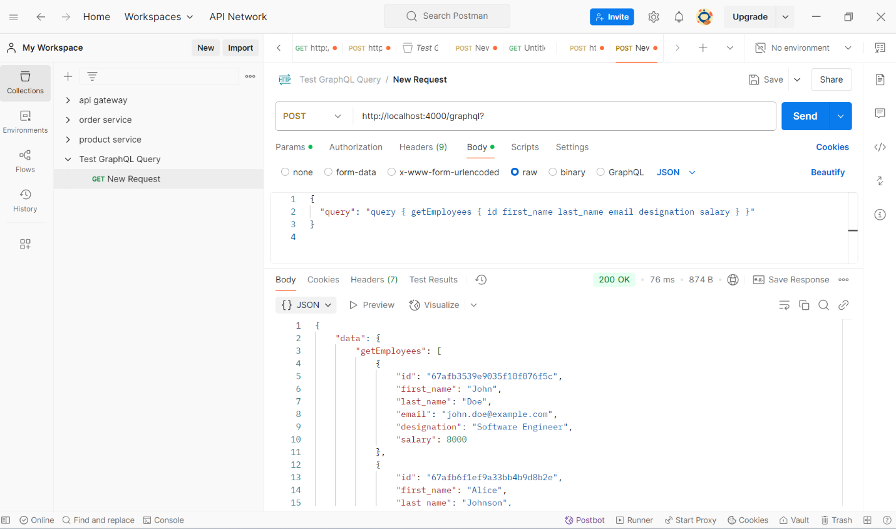Collection on MongoDB Atlas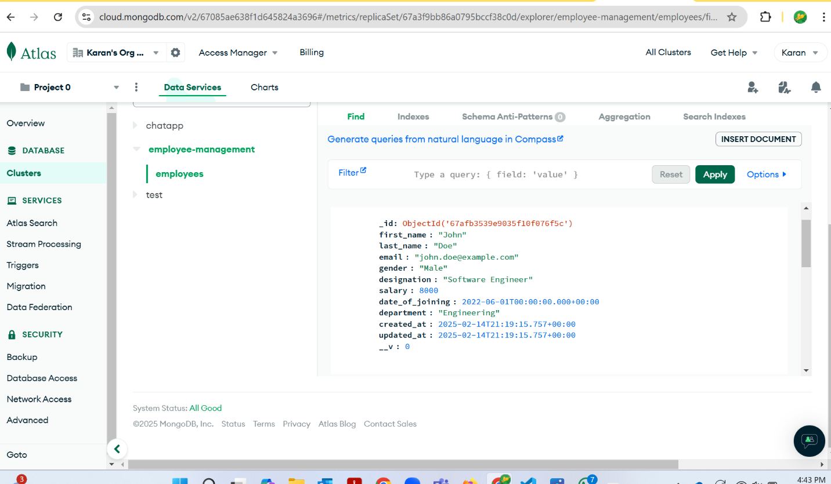
To delete employee on GraphiQL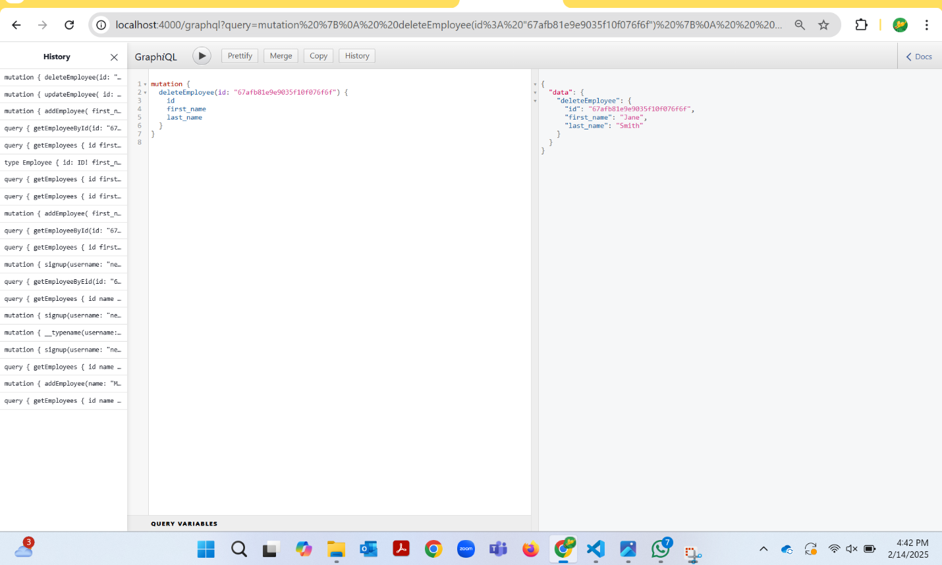To update employee on GraphiQL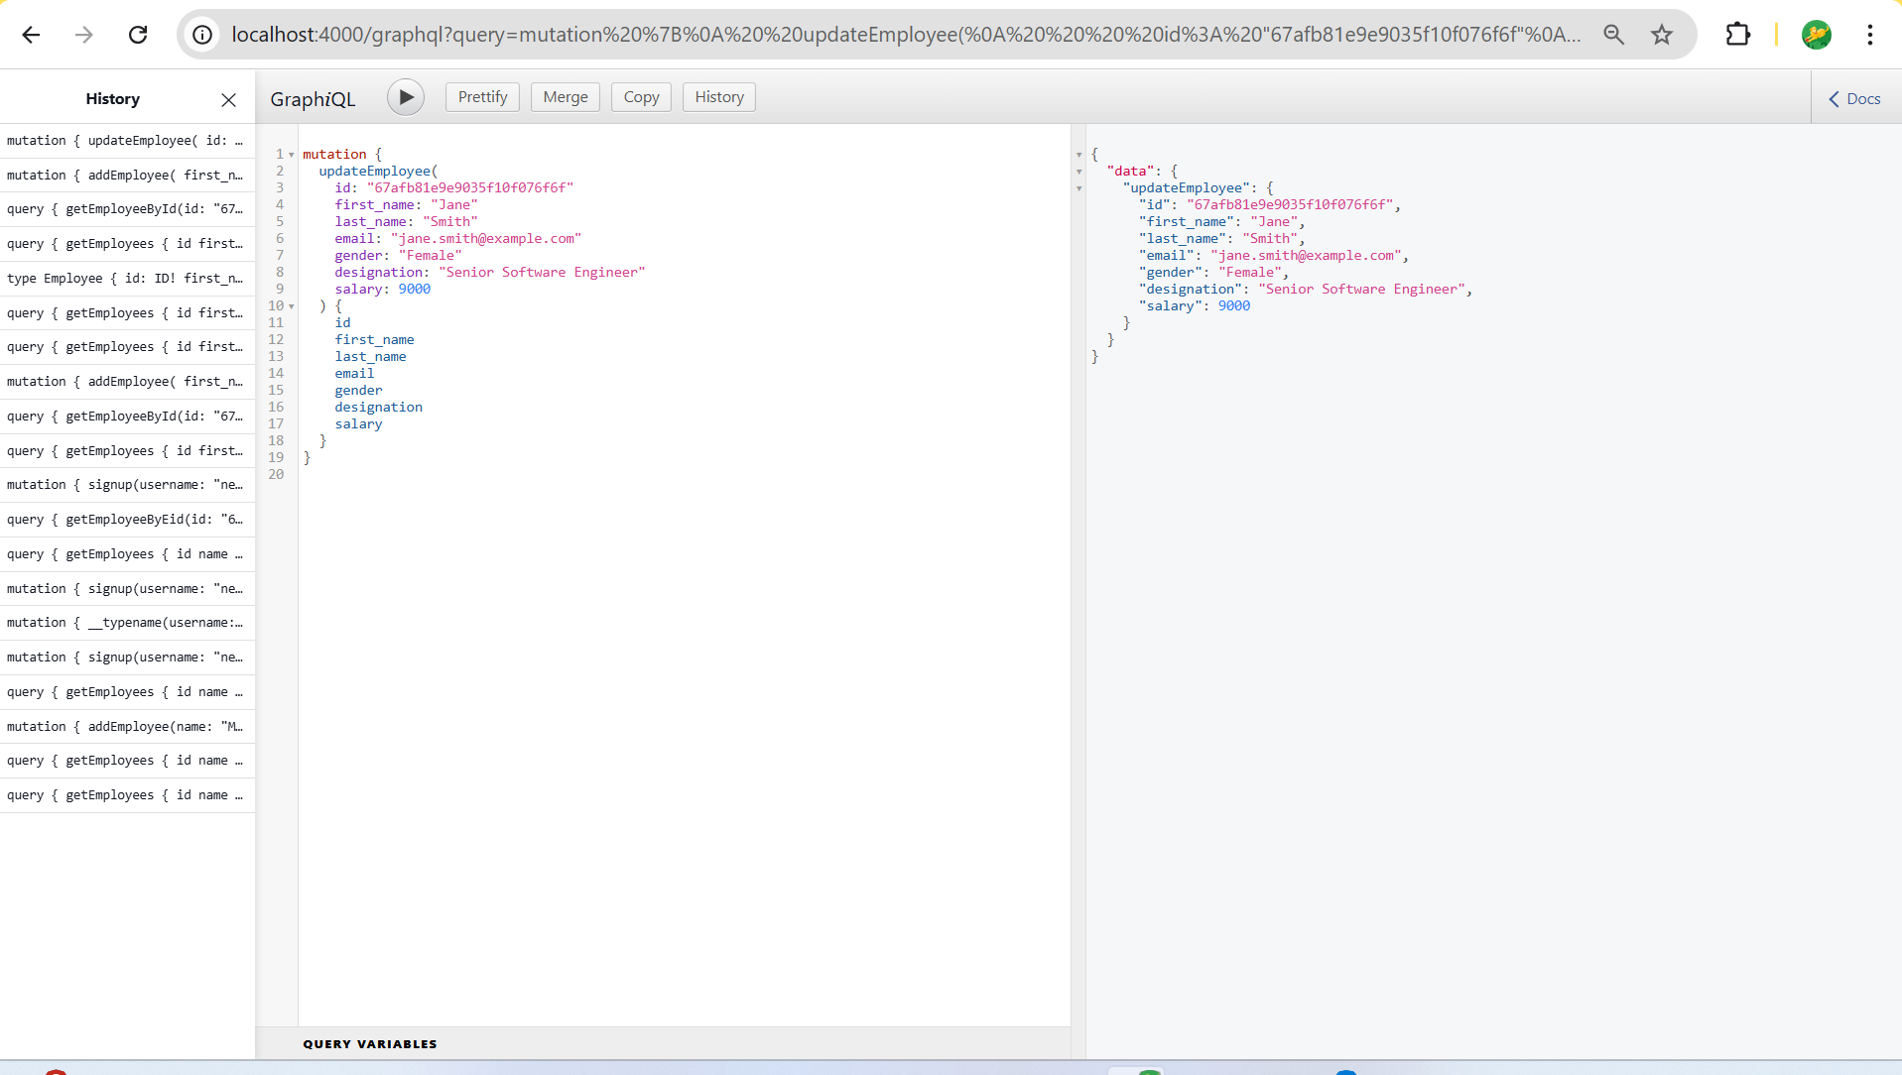
To search an employee by ID on GraphiQL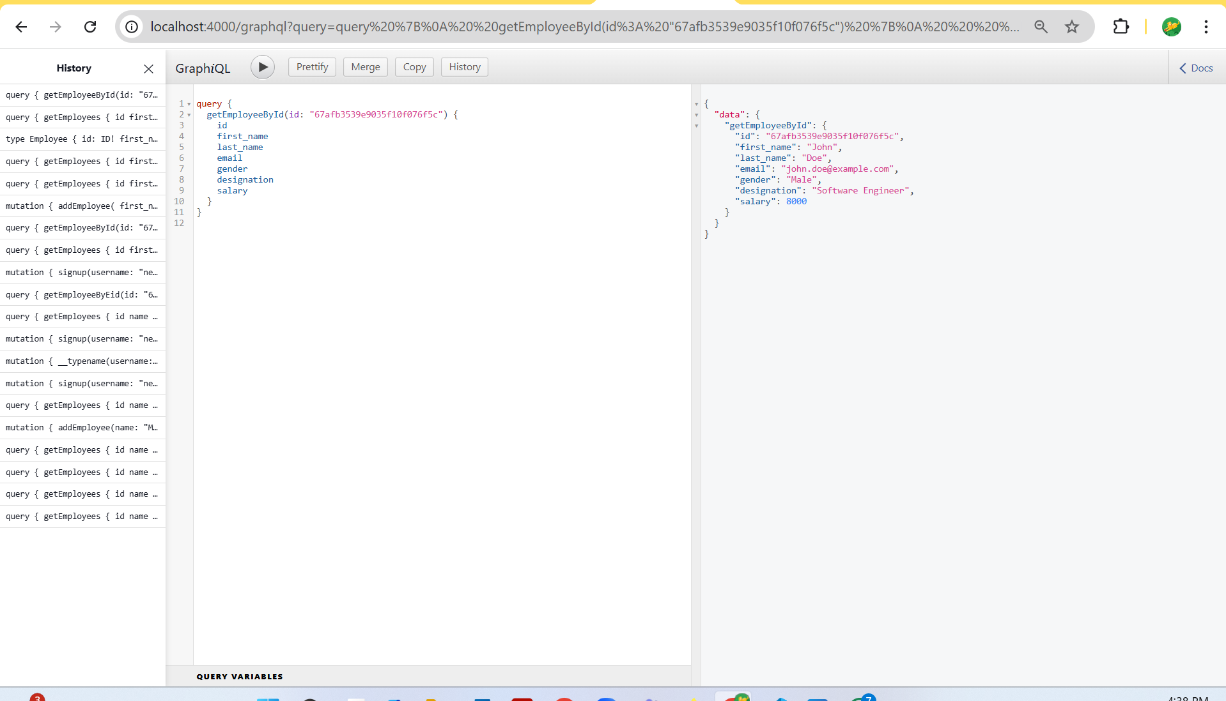
To add employee on GraphiQL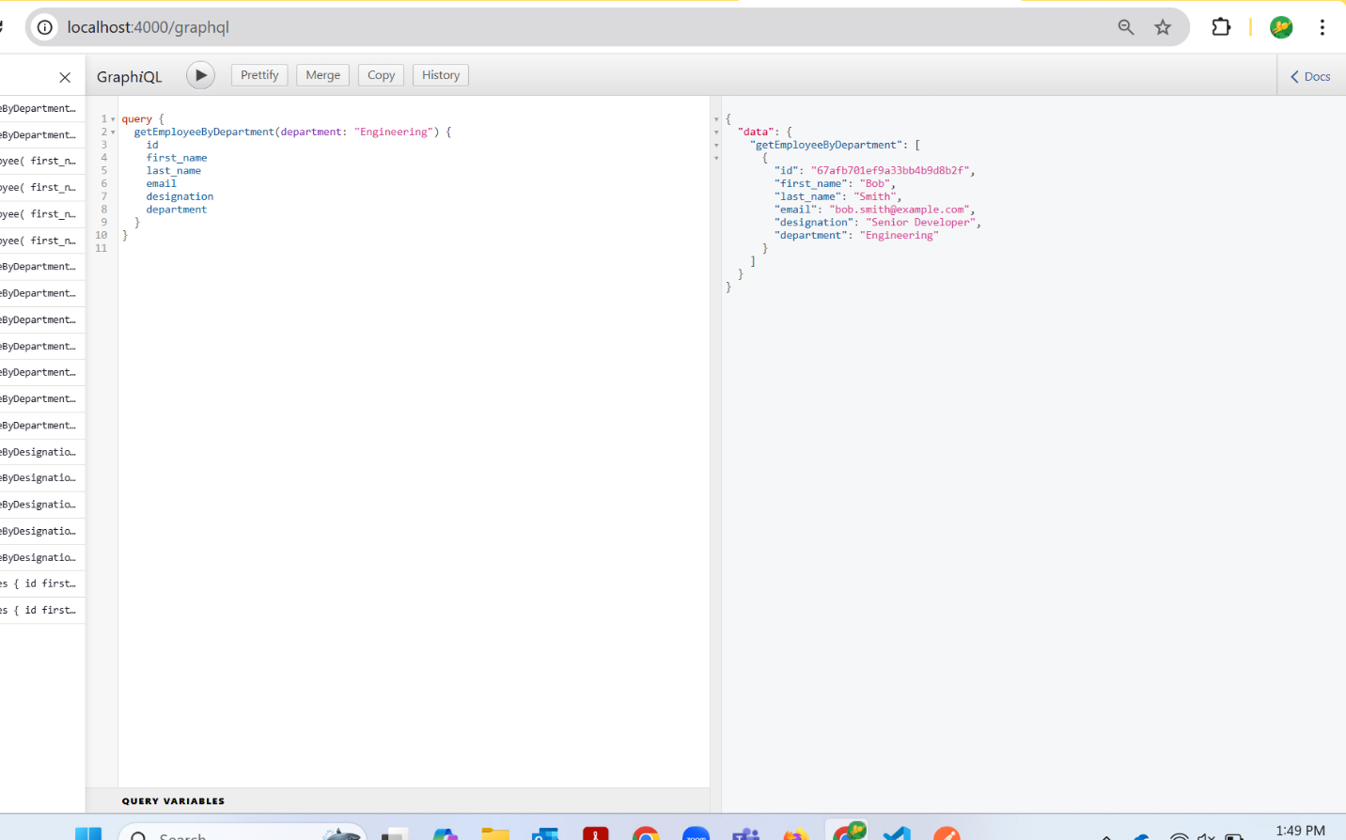
To get all employee on graphiQL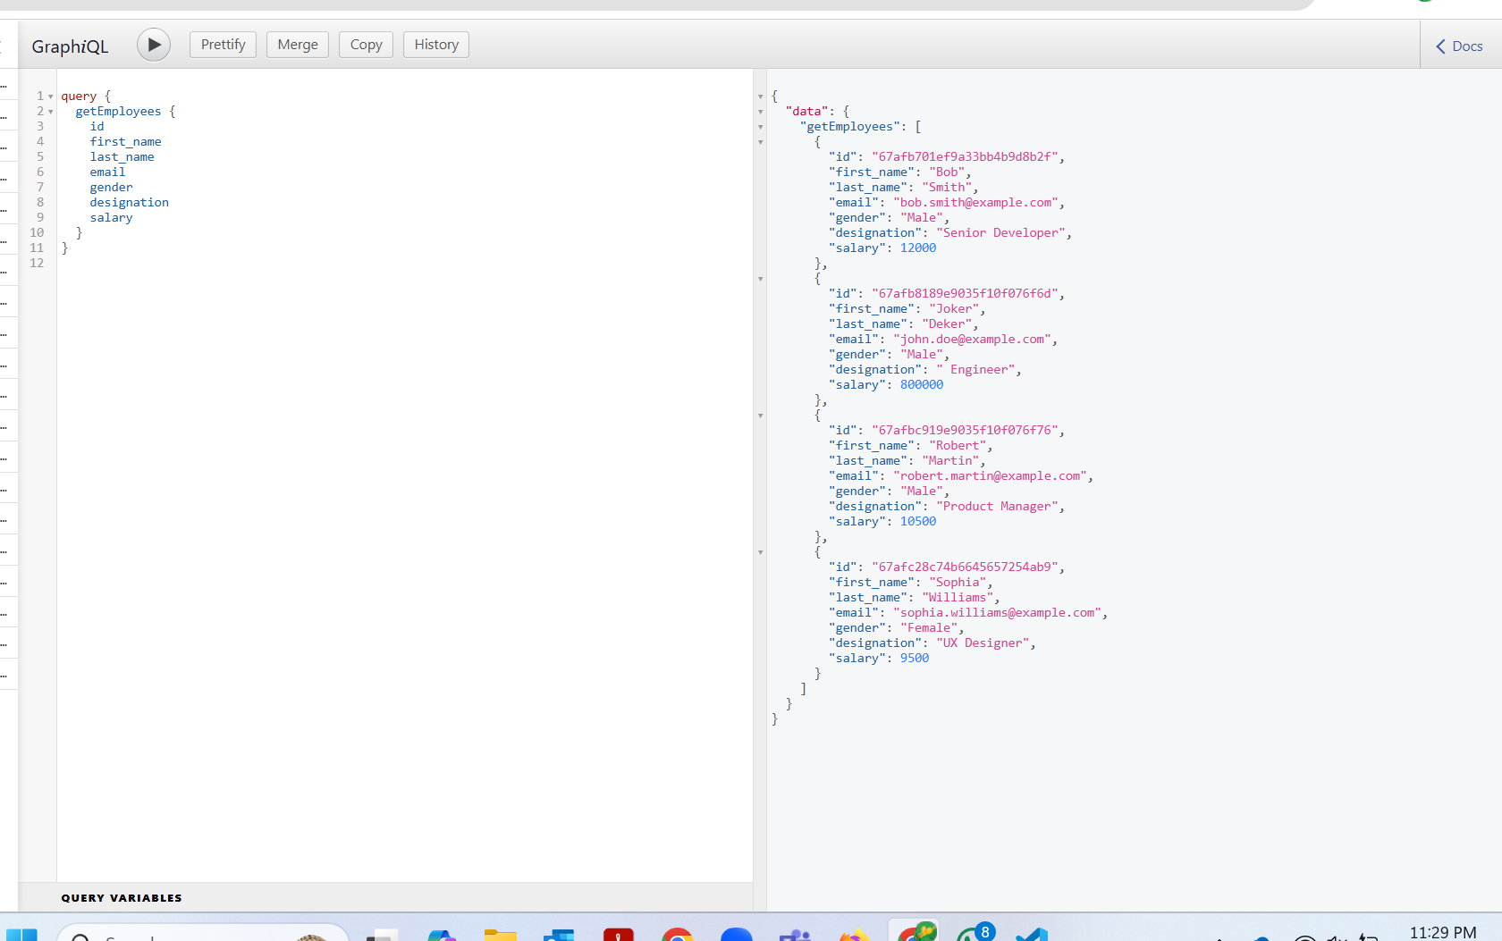
To signup on GraphiQL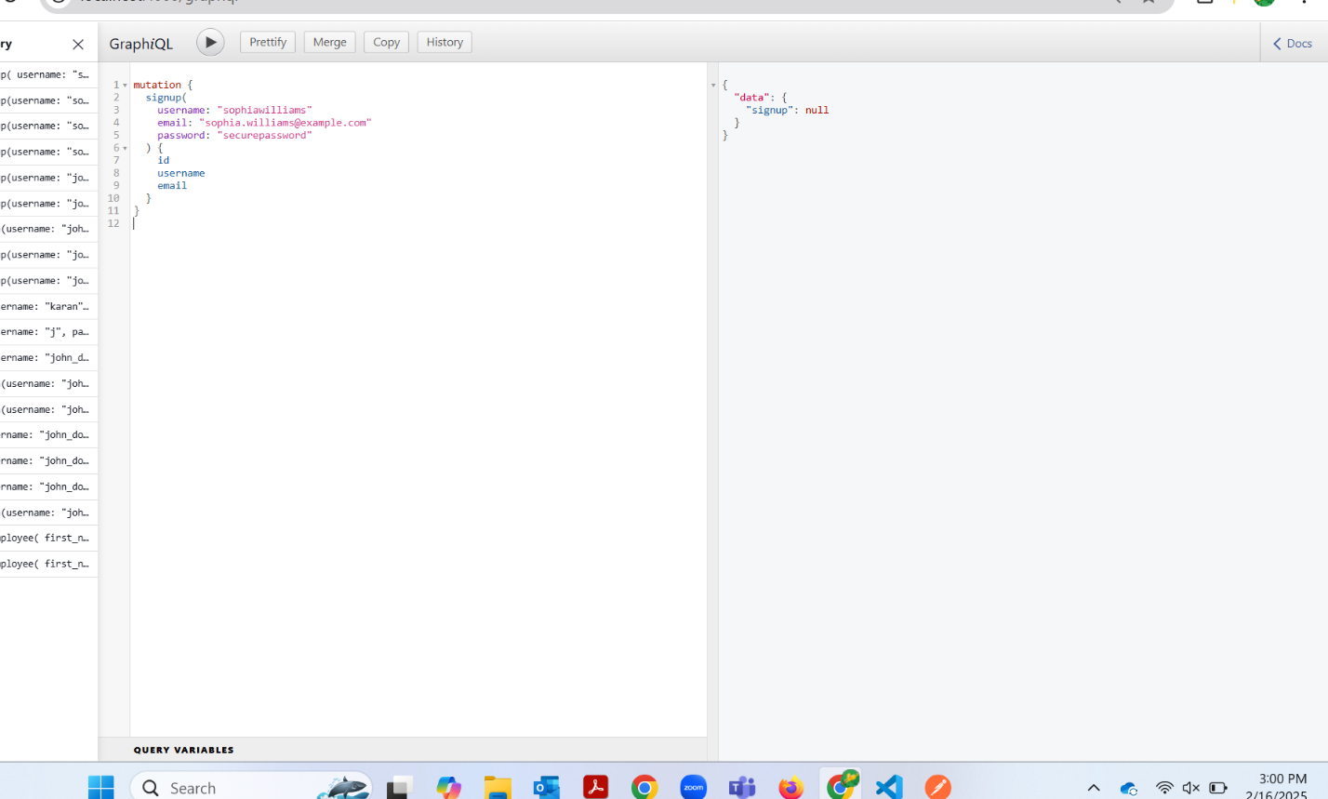
To get an employee by department on GraphiQL 